**Notes from Excel course**

July 27-29, 2020 Instructor: Heeral Patel

Tips to analyze csv/xlsx datasets:

1. Open the csv file in Excel and save it as an excel workbook because a csv file will not hold anything other than text (no formulas, visualizations, etc.,), and because you want to leave the original file untouched.
2. Freeze the top row (and first column if necessary).
3. Format the column headers so that they stand out (use bold letters, change background and font color).
4. Sometimes it helps to center the data in the cells (left vs right and top vs bottom).
5. Apply filters to all columns and check that the distinct values in each of the columns make sense. Check any strange data. Decide how to correct the data or delete it, but in either case, take notes on the reasons for your decision (e.g., obvious errors or a very small amount of data that can be deleted, data that you change because you realize what the correct entry should have been, etc.)
6. Check that the format of the columns make sense (numbers, text, dates, currency).
7. Decide which columns you want to keep, delete the others.
8. For the columns with text, recreate them using =TRIM(PROPER(Cell)) or =TRIM(UPPER(Cell)) to delete unwanted spaces. Then copy them as values on top of the original text columns and delete the columns with the trim formulas.
9. Create any field you need (a column with averages, a column with country names instead of country codes, any field you would like to use as a slicer in a dashboard).
10. If you need to look up values from another table, INDEX MATCH has advantages over VLOOKUP: it’s faster, it can look up values to the left or the right of the reference column, the formula doesn’t break if the look up table is changed (for example if columns are shifted or new columns are created). If available, use XLOOKUP instead.
11. Decide what kind of report you need to do: static or dynamic (i.e., based on pivot tables).
12. For tables and static reports remember you can use conditional formatting to easily convey some information visually (adding colors or icons based on rules).
13. If the dataset is very large, over a million rows, use Tableau or Power BI. Also use them if the reports are something you need to make and update constantly.
14. Clean your data as much as possible before making pivot tables.
15. In a pivot table, if you have dates as a field, you can right click on it and group dates by year, month, etc.
16. If the dataset is small and the report is a one-time thing, you can create your dashboard in Excel. Advantages: almost everyone and every company is familiar with it. Most companies do not have Tableau and Power BI and they still work with Excel.
17. When building dashboards in Excel, make sure your slicers are referencing the exact same range of columns and rows so that they can work on multiple pivot table results.
18. In an Excel dashboard it’s best to make a table manually and bring the results of the corresponding pivot table using =Cell. Pivot tables are less flexible to formatting, if anything is updated the pivot table can revert to a default format and you can lose all your formatting work.
19. Make the report/dashboard attractive. Play with font placement, size and color, line formatting in tables and graphs, background colors, slicer formats, etc. The better it looks the more professional you look.
20. In your dashboard, it’s a good idea to add the date of the dashboard, for example stating : “Data as of: MAX(date of the data source). This way, users will know the time extent of the data that the dashboard is referring to.

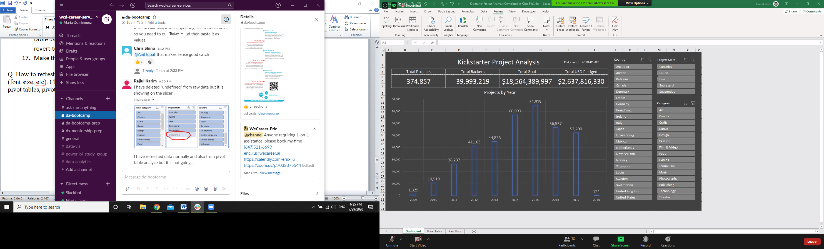

1. To refresh a slicer, for example if it’s displaying NAs that are no longer in the raw data, click on the slicer, click Slicer Settings, click on “Hide items with no data”. Or click on one of the pivot tables, pivot table options, data tab, and in “Retain items deleted from the data source” choose None.
2. You can only format the fonts of custom slicers that you create yourself.
3. Options for protecting a workbook:
4. Hide the raw data and pivot tables. Right click a sheet tab and click, choose Hide. Only leave the Dashboard unhidden.
5. Choose Review 🡪 Protect Workbook. Without a password, for example to share within your company, or with a password if needed (make sure you save it because if not, you will not be able to unprotect the workbook)
6. Choose Review🡪 Protect Sheet with or without password, and choose what users can and can’t do with a sheet, for example to protect the dashboard form modifications by the viewer (usually just check the last 3 options). For this option you have to do it for each sheet you want to protect.
7. For sensitive information: File 🡪 Info, Protect Workbook🡪 Encrypt with password.